Now as I sit Reflecting on my literary journey, I cannot help but marvel at the profound transformation it represents. From the early struggles of forming my first letter and nervously reading in front of my peers, I have evolved into a confident storyteller who can vividly convey personal experiences through words. Those initial challenges, once daunting, gradually yielded to perseverance, guidance, and growth. Literacy transcends mere reading and writing; it is a means of expression and exploration, a tool for crafting worlds and evoking emotions. My literacy journey is a testament to the power of persistence and adaptation, mirroring life's continuous process of learning and evolving, reminding me that embracing the world of words holds transformative potential for us all.

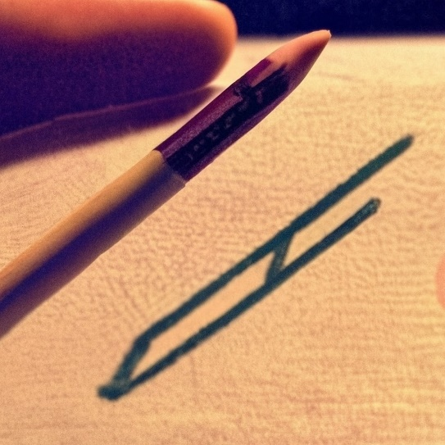As I take a stroll down memory lane, I find myself transported back to that unforgettable morning. The air was crisp, and there was an invigorating chill that made this day stand out, a memory that might have otherwise faded into the background of my childhood. I remember the scent of maple wood filling the room, mingling with the smooth, velvety glide of my pencil as it danced across the trembling, creaking surface beneath my small hand. It was a momentous occasion when I triumphantly etched my very first letter onto the page. Even now, as time has passed, that day remains one of the most vivid and cherished memories from my early life. It resonates deeply with me because it was the beginning of a lifelong journey. The enthusiasm and excitement I felt when I formed that first letter has stayed with me through the years. To this day, I continue to write every letter with the same enthusiasm and dedication, a testament to the lasting impact of that momentous day.

On that poignant day, as I stepped through the plane's threshold, the weight of a looming literacy rediscovery washed over me. Despite my attempts to evade it, the notion trailed me relentlessly, echoing in every corner of my vision. Much like Julie Wan's profound assertion that "being an unequivocal, unified whole. My early Chinese socialization continues to frame and disrupt my literacy.” (Julie Wan 1). My heritage literacy remained an indomitable companion on my every path. And like how Suzanne Kesler Rumsey describes Elaine in her auto-ethnographic data “she has learned how to exist in an English academic setting though her family abides by the traditions of the Amish within her district of Northern Indian.” (Suzanne Kesler Rumsey 575) ii also felt like I had to live through I different but equally important literacy type that had overtime shaped how I had utilized my literacy skillset.

On that fateful morning, a relentless thump-thump-thump echoed in my ears, mirroring the rhythmic beat of my own racing heart. It felt as if a rock were tumbling wildly inside a spinning dryer, a chaotic symphony of anxiety. My hand quivered with palpable intensity, reminiscent of the seismic tremors of the 1960 Valdivia earthquake. Beads of sweat cascaded from my brow like the unyielding torrents of Niagara Falls. All this unfolded as I sat there, bracing myself for what should have been a straightforward task: my first essay assignment. As I grappled with the blank page before me, doubt gnawed at my confidence. I couldn't help but question myself, "Am I truly a writer?" It was a moment of profound uncertainty. However, I recalled the wisdom of Peter, who once said, "A writer, I think, may be someone who's creative in writing and making stories come true to live" (Peter 55). In retrospect, I may not have considered myself a writer at that point, but I found solace in the notion that the act of crafting sentences, poems, or even a few lines in a diary could indeed define one as a writer, as suggested by Rose (54-55). Yet, I also resonated with the perspective of both Peter and Nate concerning the social significance of writing. Nate's assertion that writing affects people with diverse beliefs and principles (Nate 55) struck a chord with me. To me, a writer is more than just someone who puts words on paper; a writer possesses the extraordinary ability to conjure entire worlds, to depict war and peace, love and hatred, life and death, characters and their growth, heroes and villains, and the profound impact of loss. These creations emerge from the depths of a writer's imagination and come to life through their words. In doing so, writers have the power to inspire, challenge, and engage individuals from various walks of life, regardless of their beliefs and principles. It is in this profound ability to bridge differences and connect with human experience that I believe a true writer finds their purpose and significance.

The memory is etched in my mind as if it happened just yesterday. There I stood, right in front of my classmates, my heart racing like a sprinter on steroids, and to borrow a line from Eminem, "His palms are sweaty, knees weak, arms are heavy" (Eminem, 2002). It was the moment I had to read a text aloud for the first time in front of my class. As I grappled with the words, it felt like thousands of knives were digging into my nerves. The weight of my classmates and teacher's eyes fixed on me was palpable. That one excruciating minute ranks as one of the most profoundly human and uncomfortable experiences I have ever navigated. As a result of that challenging experience, my presentation skills have shown a remarkable and steady improvement. I have evolved into a confident storyteller who can artfully convey personal experiences through words.

As I pause to contemplate my literary journey, I cannot help but marvel at the profound transformation it embodies. This journey began with humble beginnings, from the earliest struggles of forming my very first letter to the nerve-wracking moments of reading in front of my peers. However, with the passage of time, these challenges gradually gave way to perseverance, guided by mentors, and nurtured by personal growth. Today, I stand as a confident storyteller, adept at skillfully weaving personal experiences into vivid narratives through the power of words.

Source:

[Chinks in My Armor: Reclaiming One’s Voice](E://anhpham/downlao/Stylus_9_1_Wan_Chinks.pdf)

[Heritage Literacy: Adoption, Adaptation, and Alienation of Multimodal Literacy Tools Author(s): Suzanne Kesler Rumsey](https://www.jstor.org/stable/pdf/20457082.pdf?refreqid=excelsior%3A356e6da57c7e0d6abbed00ed4afe70a2&ab_segments=&origin=&initiator=&acceptTC=1)

[Lose Yourself by Eminem](https://genius.com/Eminem-lose-yourself-lyrics)

[NARRATIVES OF IDENTITY: THEORIZING THE WRITER AND THE NATION](https://wac.colostate.edu/docs/jbw/v15n2/young.pdf)

[Sponsors of Literacy Author(s): Deborah Brandt](https://www.jstor.org/stable/pdf/358929.pdf?refreqid=excelsior%3A7ac88ac7b74a985b53ea0295f4ceaa8b&ab_segments=&origin=&initiator=&acceptTC=1)